标题：The Co-Production of Service: Modeling Services in Contact Centers Using Hawkes Processes
作者及机构:
Andrew Daw: Marshall School of Business, University of Southern California, Los Angeles, California 90089
Antonio Castellanos: Booth School of Business, University of Chicago, Chicago, Illinois 60637
Galit B. Yom-Tov: Faculty of Data and Decision Sciences, Technion—Israel Institute of Technology, Haifa 3200003, Israel
Jamol Pender: School of Operations Research and Information Engineering, Cornell University, Ithaca, New York 14850
Leor Gruendlinger: LivePerson Inc., Ra’anana 43000, Israel
摘要: In customer support contact centers, every service interaction involves a messaging dialogue between a customer and an agent; together, they exchange information, solve problems, and collectivelyco-producethe service. Because the service progression is shaped by the history of conversation thus far, we propose a bivariate marked Hawkes process cluster model of the customer-agent interaction. To evaluate our stochastic model of service, we apply it to an industry contact center data set containing nearly 5 million messages. Through both a novel residual analysis comparison and several Monte Carlo goodness-of-fit tests, we show that the Hawkes cluster model indeed captures dynamics at the heart of the service and surpasses classic models that do not incorporate the service history. Furthermore, in an entirely data-driven simulation, we demonstrate how this history-dependent model can be leveraged operationally to inform a prediction-based routing policy. We show that widely used and well-studied customer routing policies can be outperformed with simple modifications according to the Hawkes model. Through analysis of a stylized model proposed in the contact center literature, we prove that service heterogeneity can cause this underperformance and, moreover, that such heterogeneity will occur if service closures are not carefully managed.
AI标题: 对话历史驱动服务效率突破：霍克斯过程模型优化联络中心动态路由
AI精炼: 该论文研究客户服务联络中心中的对话式服务交互建模问题，提出了一种基于霍克斯过程（Hawkes Process）的协同服务动态模型，以解决传统排队论模型忽略对话历史依赖性的局限。传统方法通常将服务时长简化为随机变量或预定义任务序列，难以捕捉异步对话中客户与代理相互激发的动态特性。作者构建了一个双变量标记霍克斯过程集群模型，将服务交互视为客户与代理共同触发的消息序列，通过时间戳、情感分析和字数统计等特征量化双方响应速率的历史依赖性，并引入代理并发任务数作为系统状态变量。基于近500万条真实对话数据的验证表明，该模型能显著提升服务时长预测精度，并通过仿真实验证明其衍生的路由策略可将服务等待时间降低5%-10%。研究进一步揭示了服务关闭策略对系统异质性的影响，为实时负载均衡提供了理论支持。
关键词:
霍克斯过程
双变量标记霍克斯过程
协同生产服务
代理并发任务数
动态路由策略
系统异质性
对话历史依赖性
消息序列激活动态
学术要点: 学术要点 1：霍克斯过程集群模型（Hawkes Process Cluster Model）|||
通过双变量标记霍克斯过程建模客户与客服的对话交互，将服务进程视为由历史对话激发的自激过程，每个消息触发后续响应速率的动态调整。|||
学术要点 2：系统性关闭（Systematic Closure）|||
区别于自然终止的对话结束策略，通过预定义规则（如静默时间阈值）强制终止服务，可能引发服务异质性并影响路由策略有效性。|||
学术要点 3：服务成功概率（Service Success Probability）|||
基于霍克斯过程强度超平面触发的系统性关闭策略，量化对话终止后无后续消息的概率，反映服务闭环的准确性。|||
学术要点 4：残差分析验证（Residual Analysis for Cluster Processes）|||
针对单变量霍克斯集群过程提出新型残差检验方法，通过对话事件转换的均匀性验证模型对历史依赖的动态捕捉能力。|||
学术要点 5：异步通信中的服务异质性（Heterogeneity in Asynchronous Communication）|||
由客服多任务处理（并发性）导致的对话节奏非线性变化，表现为不同并发级别下代理人响应速率的参数化衰减函数差异。
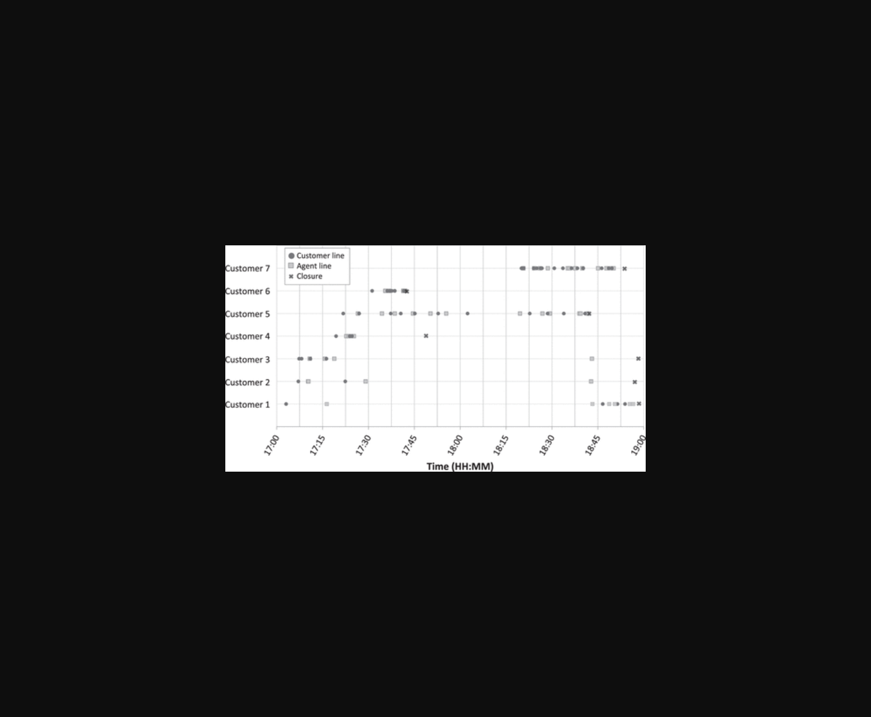
该图展示了基于霍克斯模型与经典模型的残差对比分析图。
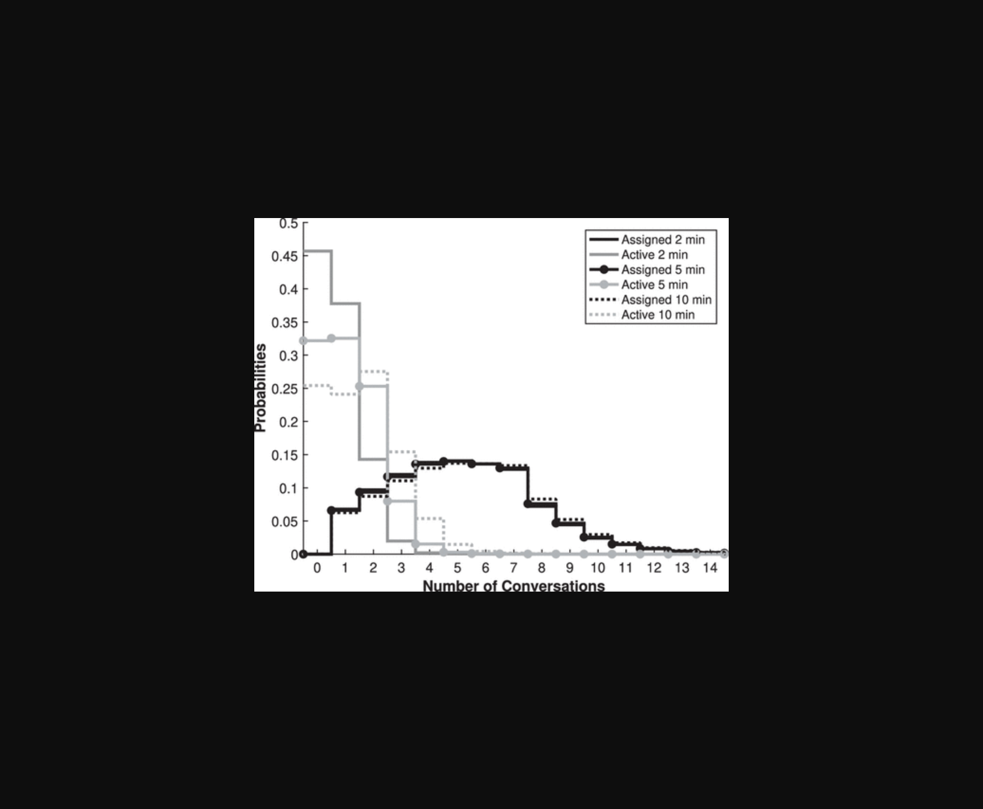
该图片展示了基于霍克斯模型的客服对话动态与经典模型残差分析对比。
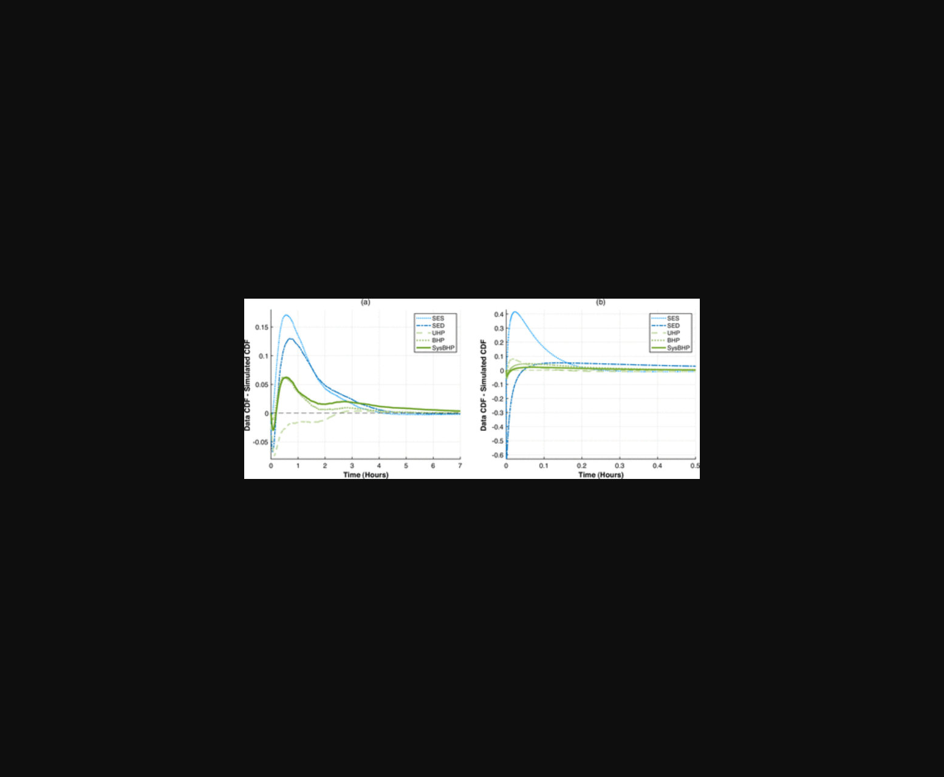
图片展示了基于霍克斯模型的客服对话动态分析及路由策略仿真效果对比图。

该图片展示了基于霍克斯过程模型的客户-客服对话事件时序模拟与真实数据对比图。
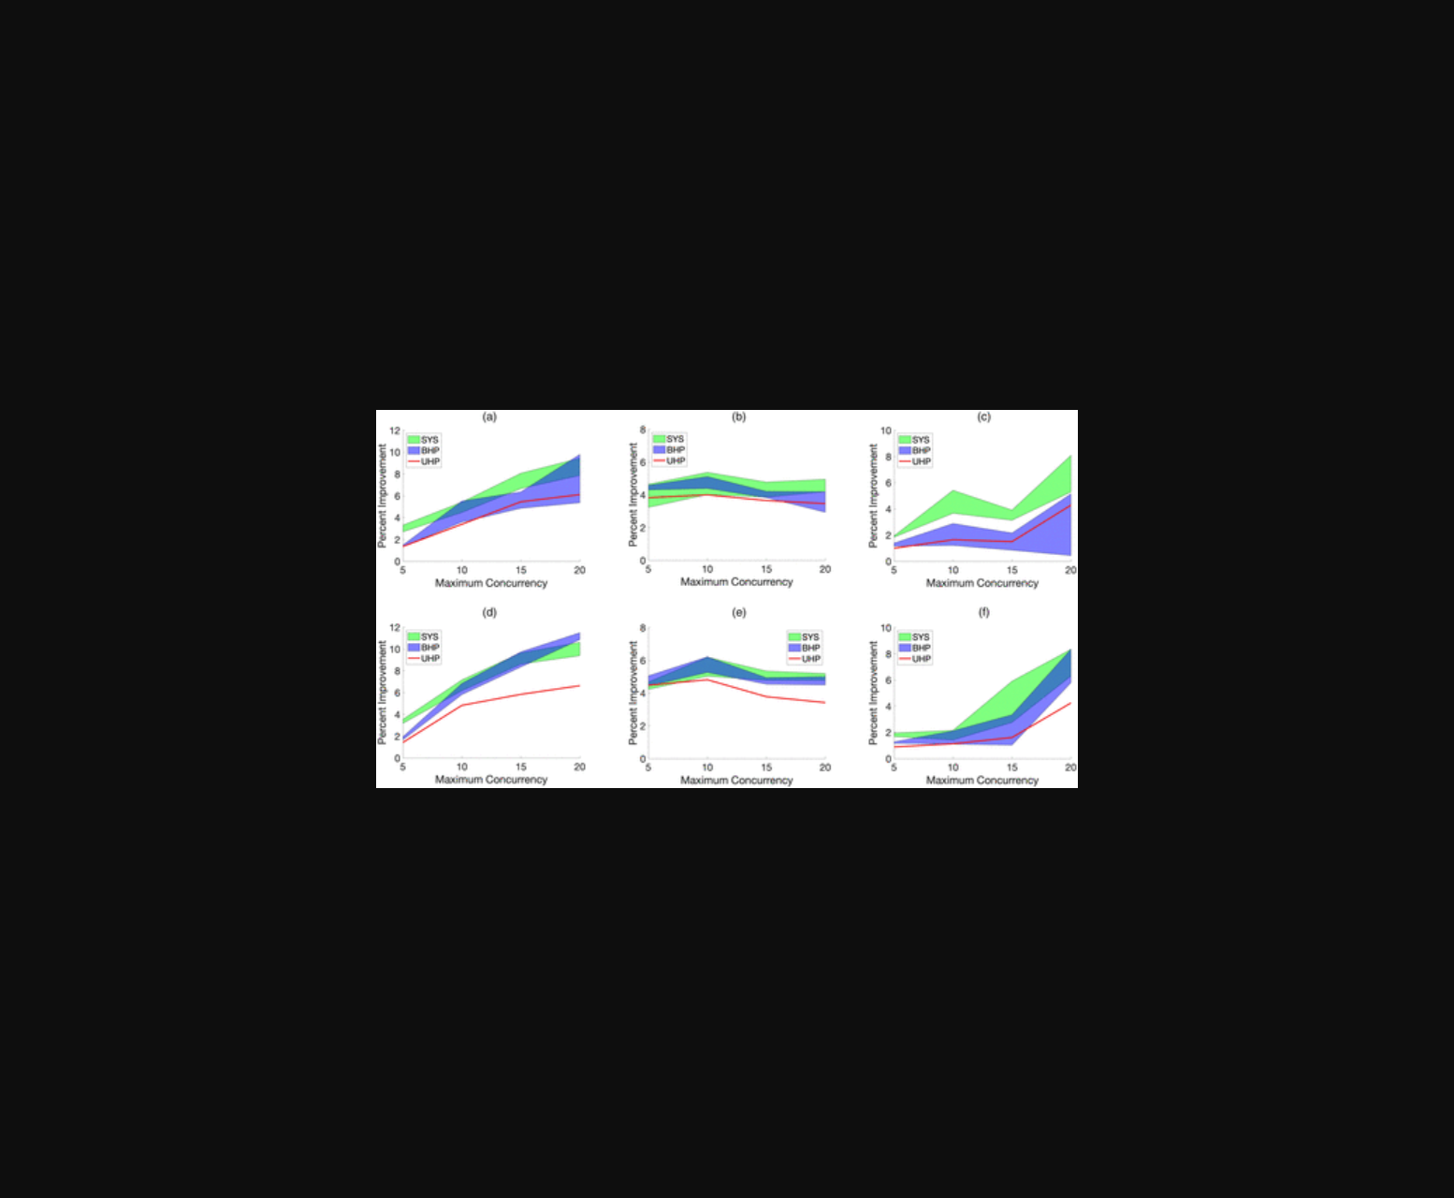
图片展示了基于霍克斯模型的对话残差分析对比及路由策略模拟效果。
原文链接: https://doi.org/10.1287/mnsc.2021.04060

